 | Sensoray  7313 SW Tech Center Drive  Tigard, OR 97223 | PRO FORMA  INVOICE  SASTRO  01/18/10
  Phone: | (503) 684-8005
  Fax: | (503) 684-8164

Timothy Pickering  South African Astronomical Observatory  P.O. Box 9  Observatory, 7935
  Phone:
  Fax:
  Email: | te.pickering@gmail.com
  Rep.: Colleen Ketterer

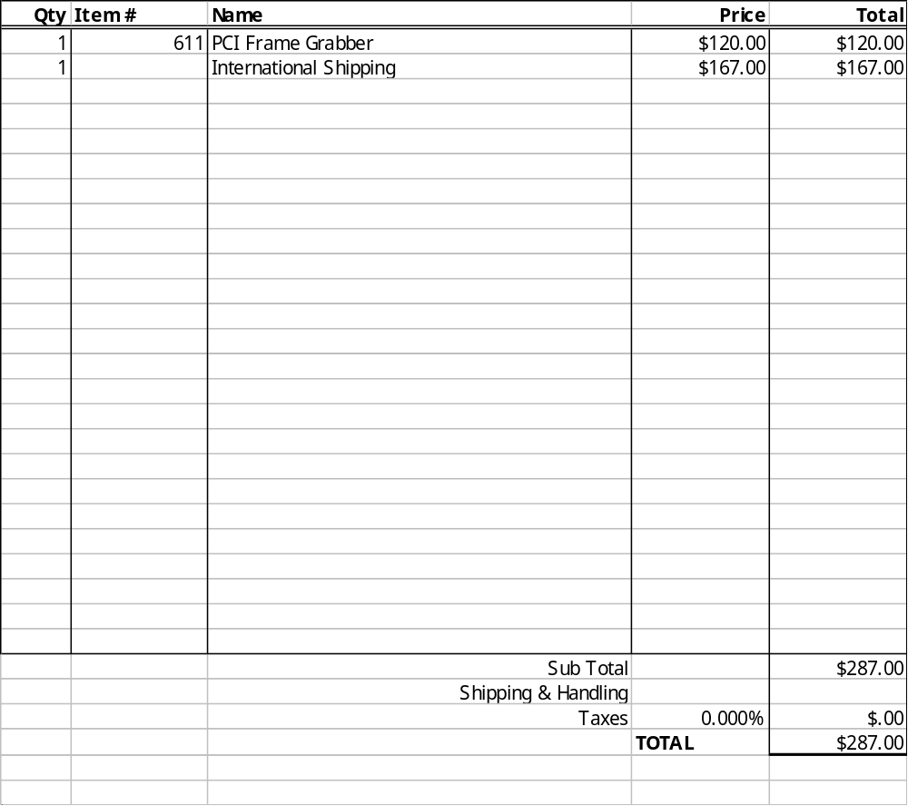
Comments: | Office Use Only:

Thank you for your business.
Quotes valid : 30-days from 11/8/2026

